**Course: Advance Bio Informatics**

**Module Title: Cyclin in Cell Cycle Regulation**

**Module No: 154**

**Cyclins in Cell Cycle Regulation**

DNA synthesis in Specified time in S phase, G1 (pre-synthetic phase), G2 (post-synthetic phase)

It is a factor for separation. Different phases of Regulation occur.

**Cyclins**

Cyclin is regulatory role proteins. Reason of name. Contact with Cdks.

Cdks: conserved, diverse functionally enzymes.

**Cyclins, Cdks & Activities**

|  |  |  |  |
| --- | --- | --- | --- |
| **Cyclin** | **Cdks** | **Active phase** | **Function** |
| D | Cdk4,Cdk6 | Late G1 | Retinoblastoma protein inactivated to repress transcription of certain genes |
| E | Cdk2 | Late G1 | Initiation of DNA synthesis |
| A | Cdk2 | S phase | Cdk2 complexes w/t cyclin A;  Completion of DNA synthesis |
| B | Cdk1 | Late G2/M | Rate limiting for transition of the cell cycle from G2 to M phase |

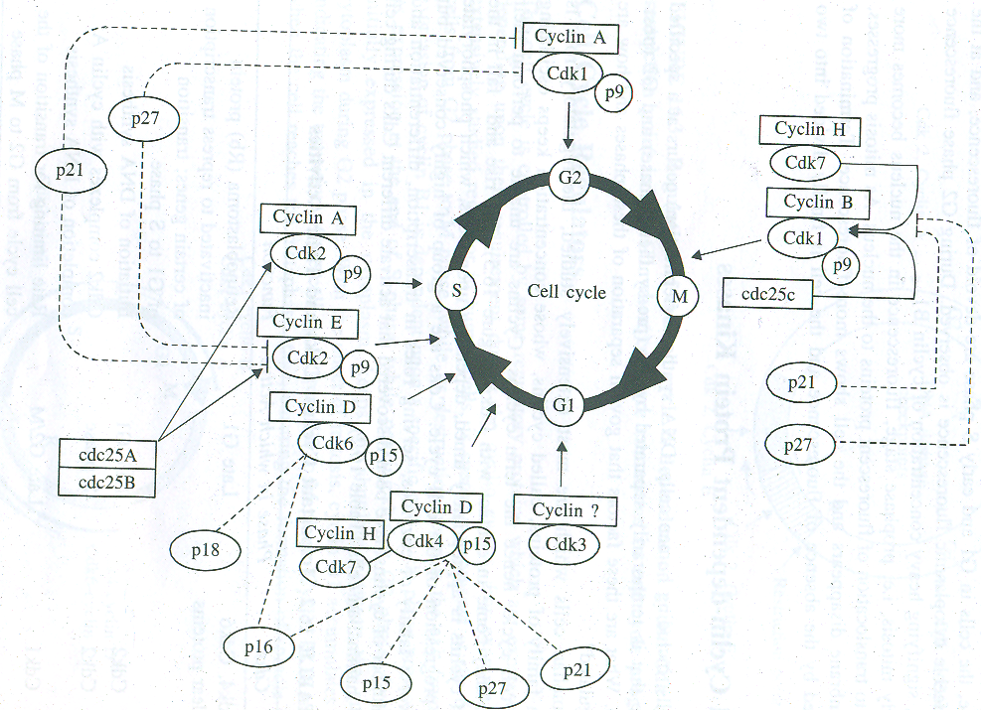

**Activity of Cyclins**

